|  |  |
| --- | --- |
| < Insight Logo>  Description: NUI_Galway_BrandMark_B | < Company Logo> |

***Enabling the Internet of Everything: a Linked Data infrastructure for networking, managing and analyzing streaming information***

Insight Galway

|  |  |
| --- | --- |
| **Author(s)** | Alessandra Mileo, Josiane Parreira, Gregor Schiele and Manfred Hauswirth |
| **Version** | V1.2 |
| **Date** | 18/02/2014 |

**Revision History**

|  |  |  |  |
| --- | --- | --- | --- |
| **Date** | **Revision** | **Description** | **Author** |
| 23/07/2013 |  | Proposal submitted via the Cisco Portal |  |
| 09/10/2013 | V1.0 | Complete draft provided |  |
| 13/02/2014 | V1.1 | Revision in progress |  |
| 18/02/2014 | V1.2 | First revision to be discussed with Cisco contact |  |
|  |  |  |  |

**Distribution List**

|  |  |
| --- | --- |
| **Name** | **Role\Purpose** |
| Keith Griffin | Cisco main contact |
| Alessandra Mileo | Insight Galway main contact |
| Josiane Parreira |  |
| Gregor Schiele |  |
| Manfred Hauswirth |  |

**Contents**

1 Project Overview 3

1.1 Mission statement 3

1.2 Objectives 3

1.3 Scope 5

1.4 Novelty 6

2 Expected Results 7

3 Key Technical Challenges 8

4 Scenario 8

5 Assumptions & Constraints 10

5.1 Assumptions 10

5.2 Constraints 10

6 Project Team 10

6.1 Core Team 10

6.2 Support Team 11

7 Project Staffing 11

7.1 Staffing Requirements 11

7.2 Hiring Strategy 12

8 Project Tasks Descriptions 12

8.1 Task 1: Data Acquisition and Federation 12

8.2 Task 2: Data Integration and Stream Processing 13

8.3 Task 3: Stream Reasoning and Knowledge extraction 13

9 Background IP 14

10 Alignments to the Insight Research Center 14

11 Communication Plans 15

11.1 Internal 15

11.2 External 15

12 References 15

# Project Overview

|  |  |
| --- | --- |
| **Project Name** | Enabling the IoE |
| **Project Funder** | SFI and Cisco Galway |
| **Project Manager** | Alessandra Mileo |
| **Principle Investigator** | Manfred Hauswirth |
| **Proposed Start Date** | 01/01/2014 |
| **Proposed End Date** | 30/03/2014 |
| **This Document Last Updated** | 18/02/2014 |
| **This Document Updated By** | Alessandra Mileo |

## Mission statement

*This Targeted Project aims at enabling the Internet of Everything in the Smart Enterprise, through a Linked Data infrastructure for networking, managing and reasoning upon heterogeneous, distributed and continuously changing data streams.*

## Objectives

The general goal of this TP is to develop an infrastructure and a general-purpose architecture that can:

* Support data acquisition from arbitrary information sources (databases, Web, IoT, phones, embedded systems, networking devices, etc.) through interoperable data models
* Support continuous interpretation of events from data, to bridge the gap between information sources and information needs across the Enterprise, setting the basis to enable faster application development in the context of Internet of Everything

These goals require a combination of new research approaches in semantic web, database, query processing and reasoning, along with development tools and experimental deployments. The detailed objectives of this project can be summarized as follows:

TP.O1 – Define and implement a flexible and scalable architecture for data/sensor fusion and deriving higher-level meaning from this input. This includes the processing, linking and discovering knowledge from dynamic and diverse sources including rich sensory-input, enterprise processes, social data and interconnected objects. The specific set of sources that we will target in this project includes a list of defined enterprise applications (including email, presence applications and calendar management), sensory-input embedded in mobile phones, geo-location, and embedded devices / sensors.

TP.O2 – Modeling and capturing the dynamics of the IoE data to increase their value, enabling stream reasoning to derive meaning from events, considering temporal dependencies and causalities between them, and sharing this meaning across applications.

The framework is organized in three processing layers - Data Acquisition and aggregation, IoE Stream Processing, and Reasoning for Knowledge Extraction - and will operate through the different life-cycle stages of data processing and utilization, supporting application development at design-time as well as application provisioning (run-time).

The processing steps and related objectives are shown in Figure 1 and are detailed below:

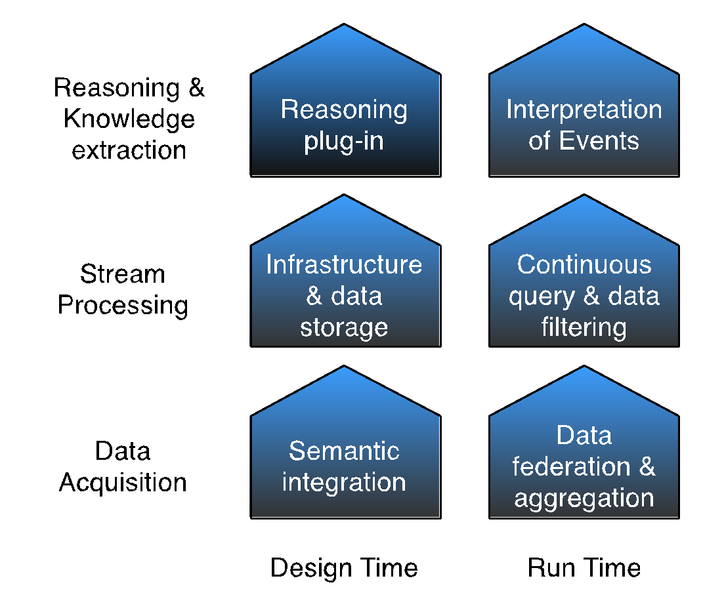

**Figure 1 - Processing steps**

* Data acquisition and federation
  + Design-time:
    - Mechanisms for easy acquisition of data streams from the identified sources, based on GSN, wrappers and RDF-on-the-Go.
    - Syntax and semantics for annotation of data streams, based on SSN extensions and related ontology models.
    - Platform based on Web Standards protocols, CoAP and CORE.
  + Run-time:
    - Semantically driven data stream discovery and federation from heterogeneous sources.
    - Adaptive integration using linked data and semantic mash-ups of Cyber-Physical resources (i.e. IoT and sensors embedded in phones).
* Large-scale IoE stream processing
  + Design-time:
    - General-purpose architecture for scalable management of Linked Streams
    - Scenario design and identification of scenario-driven parameters.
  + Run-time:
    - query-driven aggregation and summarization of time-dependent data
    - Continuous query processing for events filtering
* Reasoning and Knowledge extraction
  + Design-time:
    - Module for spatial-temporal reasoning over events.
    - Plug-in for reasoning about actions and change (Event-Condition-Action)
  + Run-time:
    - Event detection in dynamic environments.
    - Event interpretation and knowledge sharing across applications.

## Scope

Cisco has been collaborating with DERI since 2008, establishing an excellent and productive research agenda around the use of semantic technologies to create competitive innovation and new markets by harvesting, managing and understanding raw enterprise data and transforming it into knowledge. As this data grows in size and diversity, new flexible and scalable ways of abstracting, storing and processing it to extract relevant knowledge are needed. The fact that a rapidly increasing number of objects and entities are connected to the Web (phones, computers, books, people, sensors, cars, and the IoT in general) has shifted the focus from the IoT to the Internet of Everything, where the business value lies in the power of connections and the ability to create intelligence from those connections leveraging external resources in a cost-effective way. Graphs lend themselves naturally to representing this information, moving data management away from classical DB approaches to No-SQL and Linked Data databases. This has changed the technical and infrastructure requirements substantially, as can be seen by the first commercial products such as Facebook’s graph search interface. With data characteristics changing, i.e., velocity, variety, volume, and veracity, new types of all-encompassing applications become possible spanning the IoT, embedded systems, pervasive computing, the social Web and the Web in general. On the data management and reasoning sides, this means that a paradigm shift is happening: Data is mostly data streams; time and space are not mere metadata anymore; and data is heterogeneous and multimodal. This requires new integrated approaches and infrastructures to cater for these requirements.

In the networking and enterprise worlds, this also opens a plethora of new opportunities for novel applications. However, a number of challenges need to be overcome, including the need for flexible general-purpose abstractions, the need to integrate data from arbitrary sources (interoperability with no control on the data schemas), the ability to deal with data dynamics, and the need for scalable and cost-effective infrastructures. In contrast to the closed-world assumptions in traditional database application scenarios, the Internet of Everything requires an open-world assumption as information will have to be integrated from unforeseeable sources with unforeseeable schemas, possibly “on-the-fly”, and not under the control of the application or its developer or an organization. For example, for tracking people as they move in a city to dynamically provide alternative routes to avoid traffic jams and other delays, arbitrary sources must be used - sensors, other cars’ GPS, people notifying of traffic jams on Twitter, technical infrastructures of the city, etc. Essentially, “whatever is there or will be there in the future”.  To make such a complex system with multiple governing “authorities” work, a large degree of “openness” is necessary at any layer of the application stack. This requires open standards and semantic descriptions at each level.

This is just an example. The number of possible scenarios is unlimited. Their commonality lies in the graph-based representation of the data and the potentially very high number of schemas which must be integrated. This TP will focus on providing efficient strategies for near-real-time data harvesting, management and interpretation for people, data, and things..

A big advantage of the approach proposed by this TP is in its openness. We can only foresee a certain number of scenarios. As we have seen in the past, the right combination of information and systems, can provide opportunities for innovation and products that have not been “planned in” into the original systems - the Web itself being the primary example. An open approach fosters this strategy and supports it by technological means.

What is Out-of-Scope?

For the objective and focus of this Targeted Project, the following activities are out of scope:

* Processing unstructured information and text mining
* Design of algorithms for behavioural pattern analysis
* Framework for Smart Application development
* Implementation of specific decision support applications, beyond the proof of concepts that are needed to illustrate the functionalities
* Design of sophisticated dashboard or complex visualization interfaces (visualization for demonstration purposes is in scope)

## Novelty

The main novelty points in this Targeted Project reside in the capabilities that enable near-real-time IoE intelligence in the proposed framework. This work goes beyond today’s ad-hoc integration and processing of heterogeneous data sources for static and streaming data, providing more flexible and efficient processing techniques that can be applied to diverse data and combine them in both their static and streaming form for timely decision support. To achieve this, we have identified the following key enabling techniques to be developed and extended, upon which the framework will be built:

* Large-scale data integration, fusion, and continuous query processing (event handling):
  + Tools for easy integration of various devices in the infrastructure, user devices (e.g. smart phones) and enterprise information.
  + Semantic annotations of data sources to ease automatic discovery and reuse for different applications
  + Federation for flexible integration of heterogeneous data sources supported by linked data principles and mash-ups.
  + Aggregation and continuous query processing to reduce the large amount of data in real-time.
* Real-time intelligence:
  + Knowledge-based methods for the interpretation of complex events to derive higher level understanding
  + Knowledge-driven information exchange
  + Knowledge-based methods to decide on the location of the computation. This employs semantic descriptions of the computing, communication and storage capabilities of the resource constrained devices.

# Expected Results

The expected outcomes and benefits beyond academic and technological innovation from this programme of research are:

* It will provide an open platform for large-scale knowledge integration and dynamic information extraction. It will generate knowledge and expertise on ad-hoc integration of new sensors and application specific on-demand federation of data streams.
* It will demonstrate how smart enterprise applications can utilise the investment IoT based operators, mobile operators and service networks have made in their infrastructure, and leverage those for the IoE.
* It will support efficient creation and provision of IoT enabled applications which will aid increasing demand in personal and business services in the IoE field.

The main tasks/milestones for this TP are summarized below.

|  |  |  |  |  |  |
| --- | --- | --- | --- | --- | --- |
| **Task** | **Task Title** | **Milestone** | **Deliverable** | **Deliverable description** | **Leader** |
| T1 | Data Acquisition and Federation | M8 | D1 | D1: Virtualization of identified data sources and on-demand federation | Gregor Schiele |
| T2 | Semantic Data Integration and Stream Processing | M12 | D2 | D2: Linked Data processing models to capture changes over time and integrate streaming data with enterprise data. | Josiane Parreira |
| T3 | Stream Reasoning and knowledge extraction | M14 | D3 | D3: Development of stream reasoning capability for dynamic knowledge extraction and sharing | Alessandra Mileo |

# Key Technical Challenges

To provide flexible solutions to application problems this TP addresses a number of interesting research problems which are “hot” topics at the moment:

1. *Integration of IoT data with other information sources*: The IoT can only be brought to fruition if the data produced by devices can be used and integrated in a simple fashion, not requiring developers to be experts in low-level technologies. The IoT community is moving actively towards Web standards, CoAP (“HTTP”) and CORE (“semantics”, M2M) being prime examples for this. We are ahead of the curve in respect to the necessary base technologies, e.g., SPITFIRE ([www.spitfire-project.org](http://www.spitfire-project.org)) [5].
2. *Heterogeneity & interoperability*: When Enterprise Data meets the Internet of Everything, the heterogeneity of the data models and the need to cater for flexible schema poses some challenges for the design of interoperable solutions with high re-usability and little configuration required [3].
3. *Architecture*: A general-purpose architecture and platform are needed. This requires integrative research in databases, graph processing, graph-stream processing, semantics, distributed systems, etc. [2].
4. *Time dependency*: information are available continuously and in a differential way.  Stream processing and reasoning technologies deal with providing the right information, at the right, place and time [1,4,6].

# Scenario

The narrative below illustrates few scenarios that motivate the work in this TP. They focus on Connected Communication and Collaboration built upon Cisco’s communication infrastructure and standards such as HTTP, bluetooth and COAP.

FictInc is a very dynamic multinational corporation that has to deal with a lot of customers across the globe, developing IT solutions and providing targeted customer support. The employees and the managers of the company have an intense schedule that requires both internal and external collaboration across offices, divisions, buildings, cities and countries. To optimise communication, collaboration as well as time and resource management,  FictInc has an infrastructure in place that connects dynamic data from sensor-enabled devices and interconnected objects with the Enterprise Ubiquitous Presence Management System, business applications and enterprise data. Such an infrastructure needs to be general-purpose and optimized to deal with streaming, heterogeneous and distributed data and meta-data (Challenge 3).

FictInc believes in the power that lies in “connecting the unconnected.” Relying on the IoE infrastructure that abstracts meaning from physical and virtual sensors and business applications, FictInc can support meetings-on-the-move.

Advances in ICT made remote meetings become more and more common in modern businesses. Many times though, business communications are often not only remote but also mobile. Relying on the processing capabilities of the IoE Linked Data Infrastructure, John is able to participate to a meeting on-the-move. As background knowledge, the meeting-on-the-move application associates certain capabilities (e.g. answer a question, sharing screen, receiving or reading a message, etc.) with some travel settings (e.g. being driving in a car, sitting on a train, waiting in a noisy lounge, etc.) and the satisfiability of certain constraints (e.g. having free hands/eyes, having good audio, being logged onto a device with a screen, etc.).

John is participating into an online meeting host by the headquarters of FictInc while traveling. Sensing capabilities embedded in John’s phone and headset (including inertial sensors and noise detectors, geo-location, light and temperature) help John getting as much as possible from the meeting while traveling, while the Linked Data approach allows easy integration and interoperability with enterprise data (such as calendar data, map of facilities in a premise, resource allocations, etc) and third party IoT data (such as weather conditions and flights schedule). The meeting starts when John is driving to the train station, with a roundtable introduction. The meeting host Evan can see from the meeting center console that John is not available for video but he is free to talk and is in a quiet area, so he lets John introduce himself first. While John is walking from the parking to the train, one of the participants in the meeting is able to ask him a question, which john can hear and reply to. While John is on a train trip to the airport, Evan needs to ask him to forward an email that contains important information for the meeting, and the request is sent as a text because John is in a very noisy wagon. At John’s turn to report, he is in the airport lounge waiting for the flight to board, in a relatively quiet area, so he can address Evan’s request to report on the product line he is responsible for, and answer all questions before boarding. The meeting goes on with further agenda items, and half an hour before the flight Evan’s gets notified that John will not be available for the next two hours, but he can now participate with video and audio as well as execute actions, in case there is something else he needs to provide before becoming unavailable. There are no further requests for John, so Evan can continue to chair the meeting as planned.

The rich amount of heterogeneous information sources are a key role for enabling efficient management of meetings-on-the-go only if they can be collected, integrated, interpreted, used and shared in the right way. The IoE framework developed in this TP will allow that by keeping track of John’s available functionalities and changing constraints at any time during the meeting, and matching those with his geo-location, travel-plan and action requests, in order to suggest John and let the other participants know when he can present slides or share information, answer an email or a message, answer a voice question, get reached by phone call, or suggest the host a rescheduling of the agenda items when you John is approaching a noisy area or still driving due to traffic conditions.

This includes

- sensing information such as inertial movements, noise, geo-location, speed

- abstracting and aggregating such information to detect simple events such as the fact that John is driving or walking for a particular amount of time, carrying his mobile closed to him, approaching a noisy area

- reason about temporal dependencies and constraint optimization from events, for extracting meaning and feasible actions, such as changing the schedule of the meeting or suggest when to ask John questions and have a view of when he is available to perform specific actions such as sharing the screen

Such capabilities would require addressing the crucial challenges of heterogeneity and interoperability in representing and integrating event streams (Challenge 2), as well as reasoning about time-dependency of events (Challenge 4). We will address this challenges providing efficient mechanism to continuously identify, integrate and filter streaming events across sources (Task 2, Activity 2.3) and by deploying a reasoning component that identifies temporal and spatial connection between events over time, extract and share meaning from event streams and shares this information across selected application channels (such as web-based or XMPP) to provide a coherent picture (Task 3).To expand their business, FictInc decides to collaborate with another company, OtherCorp, on a number of projects as part of a strategic partnership. Therefore, the management systems of both FictInc and OtherCorp have to be integrated to enable the project participants to collaborate more efficiently. Even though the two companies use different location sensing devices - OtherCorp uses active RIFD tags and QRcodes, while FictInc prefers wireless triangulation - the collaboration is straightforward since from the system’s point of view it is equivalent to just adding a new set of data sources and models. The integration is done instantly and mostly automatic. After the participating people have been identified and specified, the system is readily able to access all necessary data from both companies to communicate and plan collaboration activities efficiently.

Here, the open-world assumption and therefore the generality of the approach plays a crucial role, making the integration of multiple, heterogeneous data input a comparatively straightforward and low effort activity. After an administrator has set up the necessary access rights, the system automatically identifies the new sensors, derives their descriptions, integrates their used data schemas and can readily plan with the new sensors and data. Such technology enables employees to be more productive and effective and addresses challenges 1 and 2, which we will address through the Virtualization and Federation activities in Task 1. Data fusion comes for free out of this.

# Assumptions & Constraints

The following assumptions and Constraints have been identified for the project.

## Assumptions

Equipment

* Cisco will provide the relevant infrastructure to accommodate and test the development of the prototype
* The necessary equipment will be installed within the first phase of the project, preferably within month M6.

Technical

* Specific Scenarios needs to be decided, along with the relevant parameters such as load profiles, to drive the implementation of more scalable solutions
* The specification of such Scenarios and parameters will be driven by Cisco Galway and completed by month M4

Resources

* Core project team members can be hired in-line with project schedule

Management / Governance

* Insight Galway and Cisco’s resources including senior management are committed throughout the duration of the project to the delivery of the outcomes.

## Constraints

Resources

* The proposed resources needed from Cisco Galway to support the different activities are indicative and need to be confirmed before the project starts, and constantly maintained in line with the project timeline.

Technical

* At the end of each project phase the team will produce a demonstrable system that represents a proof of concepts of the capabilities and functionalities developed throughout the project.

# Project Team

A core team (to be finalized before the project starts) will drive the project. A wider group from both Insight Galway and Cisco will also support the project. The list of people, roles and allocation for both the core and the support teams are illustrated in tabular form in Sections 6.1 and 6.2.

## Core Team

|  |  |  |  |  |
| --- | --- | --- | --- | --- |
| **Team Member** | **Employer** | **Grade/Point** | **Role & Responsibility** | **Allocation** |
| Prof. Manfred Hauswirth | Insight Galway |  | Principal Investigator | M1-M14 @ 5% |
| Dr. Alessandra Mileo | Insight Galway |  | Research Fellow, Project leader   * Leader: T3 * Supports: T1, T2 | M1-M14  @20% |
| Dr. Josiane Parreira | Insight Galway |  | Research Fellow   * Scientific Leader T2 * Supports T1, T3 | M1-M14 @20% |
| Dr. Gregor Schiele | Insight Galway |  | Research Fellow   * Scientific & Technical Leader T1 * Supports T2, T3 | M1-M14  @20% |
| Dr. Keith Griffin | Cisco |  | Main contact for sign-off of deliverables and work plan | M1-M14 @5% |

## Support Team

|  |  |  |  |
| --- | --- | --- | --- |
| **Team Member @%** | **Employer** | **Position Title** | **Role & Responsibility** |
| Dr. Ali Intizar @50% | Insight Galway | Postdoctoral Researcher | Design and Implementation of algorithms for on demand Federation of data streams |
| Dr. Danh Le Phuoc @15% | Insight Galway | Research Fellow | Stream Processing Infrastructure Development |
| New hire @20% | Insight Galway | Project Manager | Project management |
| Zia Ush Shamszaman @20% | Insight Galway | PhD Student | Research and Development on Query Federation and Optimization |
| Shalki Shrivastava @100% | Insight Galway | Master Student | Research and Development on Stream Reasoning |
| New  hire @100% | Insight Galway | Senior Software Engineer | Development |
| New hire @100% | Insight Galway | Junior Software Engineer | Development |
| TBD | Cisco Galway |  |  |

# Project Staffing

## Staffing Requirements

Staffing will take place until month 4.

## Hiring Strategy

In order to recruit the best possible people, we will constitute a panel that involves senior members of Insight Galway, and we will share CVs of shortlisted candidates with Keith Griffin as the main Cisco contact for sign-off.

# Project Tasks Descriptions

In order to achieve the objectives TP.O1-2, the work plan of this targeted project is structured into three different technical tasks, as illustrated in Figure 2, using the application scenarios described in this document. An additional management task (T4) is in charge of finalizing the WP description to be completed within M3.

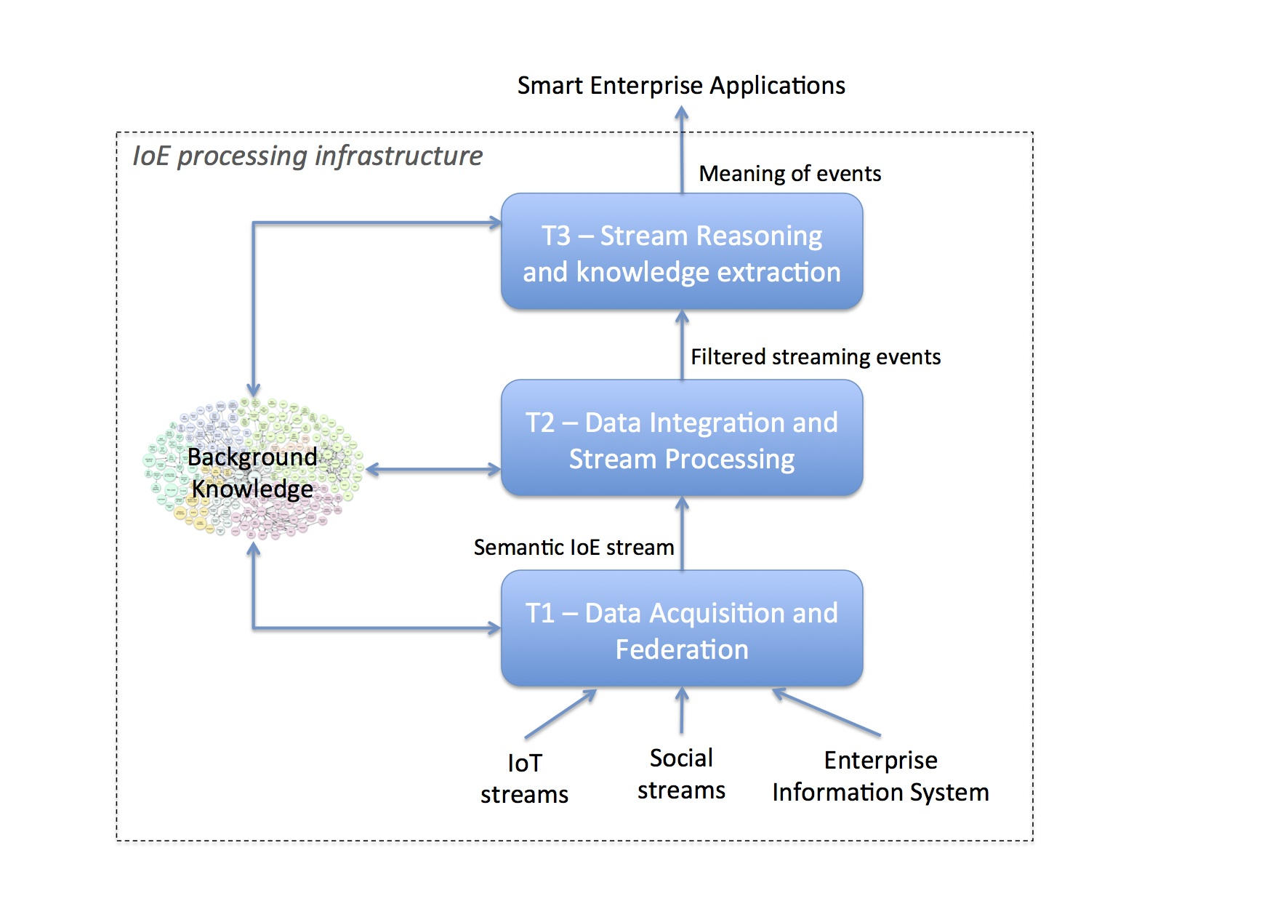

**Figure 2 - Work Plan structure**

Each task includes several activities as listed in the following.

## Task 1: Data Acquisition and Federation

**Objective:** The main objective of this task is to provide mechanisms for acquisition and representation of data streams from heterogeneous sources with high reusability and low configuration effort. The on-demand federation mechanism will enable access to streaming data.

**Description:** This task will be divided into two main activities:

* **Activity 1.1**: Resource Access Virtualization via GSN wrappers and Semantic Annotation based on the SSN ontology
* **Activity 1.2**: On-demand data federation across sources

## Task 2: Data Integration and Stream Processing

**Objective:** The main objectives of this task are the continuous integration and filtering of data streams. This is done via efficient continuous query processing, extending the Enterprise background Knowledge with linked data streams.

**Description**: This task will be divided into two activities:

* **Activity 2.1**: Scenario specification and identification of relevant parameters, providing use case diagrams, sequence diagrams, class/object diagrams and configuration parameters such as load profiles, to drive the implementation of more scalable solutions
* **Activity 2.2**: Continuous Query Processing over Linked Streams to capture, integrate and filter streaming events

## Task 3: Stream Reasoning and Knowledge extraction

**Objectives**: The main objective of this task is that of combining efficient stream query processing with reasoning mechanisms that can help deriving meaning from events (e.g considering time-dependent correlations, geolocations as well as virtual presence, preferences and priorities) and sharing this meaning across applications.

**Description**: This task will be divided into three main activities:

* **Activity 3.1**: Deployment of a spatial-temporal reasoning component for the interpretation of complex events.
* **Activity 3.2**: Design and deployment of the Stream Reasoning Event-Condition-Action component that determines how the meaning of events  identified in A3.1 should be used and shared across applications.
* **Activity 3.3**: Identification of target existing applications and integration of  communication channels with such applications (e.g. HTTP, XMPP)

A draft of the resources and the responsible for the outlined activities is summarized in Table 1, while the Gantt chart is illustrated in Table 2.

It should be noted that this Work Plan will be periodically revised and will timely evolve according to finding and new results in related areas. This might also include further prioritization of the research activity based on industry trends and resource allocation, and may include additional topics along with additional contribution as required.

**Table 1 - Effors and Timeline**

|  |  |  |  |  |  |  |
| --- | --- | --- | --- | --- | --- | --- |
| **Activity Ax.y** | **Responsible** | **PM INSIGHT (estimate)** | **PM CISCO (estimate)** | **People Involved** | **Start MM** | **End MM** |
| A1.1 | Dr. G. Schiele | 4PM | -- | (RA) N. Niranjan | 4 | 8 |
| A1.2 | Dr. A. intizar | 2PM | -- | (PhD) Z. Shamszaman | 6 | 9 |
| A2.1 | Dr. A.Mileo | 2PM | 1PM | Dr. Ali Intizar, (PhD)A. Thur | 4 | 8 |
| A2.2 | Dr. J. Parreira | 6PM | -- | Dr. Danh Le Phuoc | 6 | 12 |
| A3.1 | Dr. A.Mileo | 5PM | -- | (Master), S. Shrivastava | 6 | 12 |
| A3.2 | Dr. A. Mileo | 5PM | -- | PhD student, A. Thur | 6 | 14 |
| A3.3 | Dr. M.  Serrano | 2PM | 1PM | (RA) N. Niranhan, | 10 | 14 |

**Table 2 - Gantt Chart**

|  |  |  |  |  |  |  |  |  |  |  |  |  |
| --- | --- | --- | --- | --- | --- | --- | --- | --- | --- | --- | --- | --- |
| **Project month:** | 1-3 | **4** | 5 | **6** | 7 | **8** | 9 | **10** | 11 | **12** | 13 | **14** |
| Task 4 |  |  |  |  |  |  |  |  |  |  |  |  |
| Activity 1.1 |  |  |  |  |  |  |  |  |  |  |  |  |
| Activity 1.2 |  |  |  |  |  |  |  |  |  |  |  |  |
| Activity 2.1 |  |  |  |  |  |  |  |  |  |  |  |  |
| Activity 2.2 |  |  |  |  |  |  |  |  |  |  |  |  |
| Activity 3.1 |  |  |  |  |  |  |  |  |  |  |  |  |
| Activity 3.2 |  |  |  |  |  |  |  |  |  |  |  |  |
| Activity 3.3 |  |  |  |  |  |  |  |  |  |  |  |  |

# Background IP

Any background IP that is declared as either included or excluded for access rights has been listed as part of the contractual agreement that accompanies this description of work. It is the duty of all personnel working on this project to ensure that they are aware of the implications of this.

# Alignments to the Insight Research Center

This project is related to the following work packages in the INSIGHT proposal, in particular:

* Rules and Query processing for large-scale data management

# Communication Plans

The project will develop a plan for both internal and external communication.

## Internal

* Mailing List, Confluence Wiki, Basecamp and JIRA run by Insight Galway
* Daily Scrum, Monthly Iterations, Quarterly Steering Committee Reviews
* Demo to Senior Leadership between M10-M14

## External

* Include on Insight Website (to be decided)
* Press Release on Project Launch and Significant Results (i.e. Start-up, Completion, License deal etc.)
* International Conference Participation

# References

[1] Alessandra Mileo, Ahmed Abdelgayed, Sean Policarpio, Manfred hauswirth: “StreamRule: A Nonmonotonic Stream Reasoing System for the Semantic Web”. RR2013, 247-252.

[2]  Danh Le Phuoc, [Hoan Quoc Nguyen-Mau](http://www.informatik.uni-trier.de/~ley/pers/hd/n/Nguyen=Mau:Hoan_Quoc.html), [Josiane Xavier Parreira](http://www.informatik.uni-trier.de/~ley/pers/hd/p/Parreira:Josiane_Xavier.html), Manfred Hauswirth: A middleware framework for scalable management of linked streams. [J. Web Sem. 16](http://www.informatik.uni-trier.de/~ley/db/journals/ws/ws16.html#PhuocNPH12): 42-51 (2012).

[3] Danh Le Phuoc, [Josiane Xavier Parreira](http://www.informatik.uni-trier.de/~ley/pers/hd/p/Parreira:Josiane_Xavier.html), [Manfred Hauswirth](http://www.informatik.uni-trier.de/~ley/pers/hd/h/Hauswirth:Manfred.html): Linked Stream Data Processing. [Reasoning Web 2012](http://www.informatik.uni-trier.de/~ley/db/conf/rweb/rweb2012.html#PhuocPH12): 245-289.

[4] Danh Le Phuoc, Josiane Xavier Parreira, [Michael Hausenblas](http://www.informatik.uni-trier.de/~ley/pers/hd/h/Hausenblas:Michael.html), [Yuanbo Han](http://www.informatik.uni-trier.de/~ley/pers/hd/h/Han:Yuanbo.html), [Manfred Hauswirth](http://www.informatik.uni-trier.de/~ley/pers/hd/h/Hauswirth:Manfred.html): Live linked open sensor database. [I-SEMANTICS 2010](http://www.informatik.uni-trier.de/~ley/db/conf/i-semantics/i-semantics2010.html#PhuocPHHH10).

[5] [Dennis Pfisterer](http://www.informatik.uni-trier.de/~ley/pers/hd/p/Pfisterer:Dennis), [Kay Römer](http://www.informatik.uni-trier.de/~ley/pers/hd/r/R=ouml=mer:Kay), [Daniel Bimschas](http://www.informatik.uni-trier.de/~ley/pers/hd/b/Bimschas:Daniel), [Oliver Kleine](http://www.informatik.uni-trier.de/~ley/pers/hd/k/Kleine:Oliver), [Richard Mietz](http://www.informatik.uni-trier.de/~ley/pers/hd/m/Mietz:Richard), [Cuong Truong](http://www.informatik.uni-trier.de/~ley/pers/hd/t/Truong:Cuong), [Henning Hasemann](http://www.informatik.uni-trier.de/~ley/pers/hd/h/Hasemann:Henning), [Alexander Kröller](http://www.informatik.uni-trier.de/~ley/pers/hd/k/Kr=ouml=ller:Alexander), [Max Pagel](http://www.informatik.uni-trier.de/~ley/pers/hd/p/Pagel:Max), [Manfred Hauswirth](http://www.informatik.uni-trier.de/~ley/pers/hd/h/Hauswirth:Manfred), [Marcel Karnstedt](http://www.informatik.uni-trier.de/~ley/pers/hd/k/Karnstedt:Marcel), [Myriam Leggieri](http://www.informatik.uni-trier.de/~ley/pers/hd/l/Leggieri:Myriam), [Alexandre Passant](http://www.informatik.uni-trier.de/~ley/pers/hd/p/Passant:Alexandre), [Ray Richardson](http://www.informatik.uni-trier.de/~ley/pers/hd/r/Richardson:Ray): SPITFIRE: toward a semantic web of things. 40-48.

[6] H. N. M. Quoc, M. Serrano, D. L. Phuoc, and M. Hauswirth: Super stream collider–linked stream mashups for everyone.  In Proceedings of the Semantic Web Challenge co-located with ISWC2012, Boston, US, November 2012.

[7] Danh Le Phuoc, [Minh Dao-Tran](http://www.informatik.uni-trier.de/~ley/pers/hd/d/Dao=Tran:Minh.html), Josiane Xavier Parreira, [Manfred Hauswirth](http://www.informatik.uni-trier.de/~ley/pers/hd/h/Hauswirth:Manfred.html): A Native and Adaptive Approach for Unified Processing of Linked Streams and Linked Data. [International Semantic Web Conference (1) 2011](http://www.informatik.uni-trier.de/~ley/db/conf/semweb/iswc2011-1.html#PhuocDPH11): 370-388.